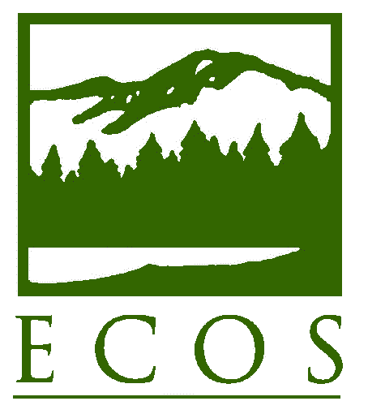

Resolution 14-01
Approved April 2, 2014
Sausalito, California

As certified by
Carolyn Hanson
Acting Executive Director

NEXT GENERATION COMPLIANCE ASSURANCE and performance measurement

WHEREAS, in September 2011, the New England States’ Environmental Commissioners presented a proposal to the U.S. Environmental Protection Agency (EPA) to initiate a process that would lead to significant improvements and upgrades in modernizing the structure and implementation of the Compliance Monitoring Strategies (CMS) for the air quality, hazardous waste, and wastewater programs; and

WHEREAS, in a follow-up meeting in December, 2011, the New England Commissioners, EPA’s Office of Enforcement and Compliance Assurance (OECA), and EPA Region 1 senior managers – along with compliance, enforcement and assistance program leads from EPA and the states – engaged in an extensive dialogue that advanced a common vision of all of the participants’ perspectives on the CMS; and

WHEREAS, EPA’s position on the these critical themes developed in that exchange was further clarified in a December 5, 2012 memorandum from Lisa Lund, Director of the Office of Compliance at OECA; and

WHEREAS, ECOS worked in partnership with the Northeast Waste Management Officials’ Association (NEWMOA) to convene a national meeting of state agencies in June 2013 focused on “Environmental Compliance Assurance and Performance Measurement Strategies” where state participants from different states and Regions expressed both a strong interest and strong support in continuing to share information and collaborate to advance cost effective approaches to compliance monitoring and performance measurement; and

WHEREAS, programs like the State Small Business Environmental Assistance Programs help inform businesses of and provide technical assistance related to environmental regulations, thereby advancing small business compliance which in conjunction with appropriate monitoring may support compliance assurance and performance measurement efforts; and

WHEREAS, state agencies in EPA Region 5 and the Regional Office collaborated over a four year period to develop a common approach to advancing compliance, monitoring compliance, and understanding compliance trends on a multi-state basis for auto body shops; and
WHEREAS, with support from EPA Headquarters ten states collaborated on a Common Measures Project for four years to develop an approach to understanding compliance rates within a regulated universe on a multi-state basis; and

WHEREAS, the Colorado Department of Public Health and the Environment has developed a model program for understanding and monitoring compliance trends among hazardous waste generators; and

WHEREAS, ECOS and EPA Headquarters helped to form and supported an Environmental Results Program Consortium involving 19 state members for many years that has focused on developing a tool box of approaches to advancing compliance and methods for understanding compliance rates within sectors ; and

WHEREAS, other state agencies across the nation have been developing cost-effective compliance monitoring and assurance strategies and developing new performance measurement approaches, particularly for reaching the growing number of smaller facilities that have significant cumulative impacts on the environment; and

WHEREAS, traditional environmental compliance monitoring strategies such as inspections and enforcement produce a great deal of information about individual facilities and are critical for environmental protection; improved technology and techniques allow for new compliance monitoring strategies to supplement traditional methods, so that inspections can target facilities that pose the greatest environmental risk; and

WHEREAS, state agencies have increasing needs to develop a tool box of compliance monitoring strategies that they can use strategically depending on the status of the regulatory requirement and the sector or groups of regulated entities to support both state and national environmental goals. These strategies which can allow for the more efficient use of compliance assurance resources are applicable to the traditional “majors” that are the focus of the Air, Hazardous Waste and Wastewater Compliance Monitoring Strategies, as well as small sources that the CMS do not address. Strategies that integrate traditional enforcement approaches along with newer ones are often most relevant when a government agency needs to understand and substantially improve the performance of a sector, because:
- The cumulative human health and environmental impact of many, particularly smaller facilities can be significant;
- Localized impacts from groups of facilities are a concern to a community;
- Smaller businesses may not understand the requirements for managing hazardous materials, wastes, discharges, and emissions and they may be in noncompliance; and
- Currently resources and flexibility are not readily available to inspect smaller facilities in significant numbers; and

WHEREAS, the section of EPA’s draft FY 14–18 Strategic Plan on “Next Generation Compliance and E-Enterprise” supports more innovative approaches for compliance monitoring, advancing compliance using incentives and other methods, and enforcement with the possibility of providing credit for innovations that avoid violations, such as through pollution prevention and other techniques; and.

WHEREAS, many states have long sought a clear, predictable, and manageable methodology from EPA on how to get approval for alternative compliance assurance strategies including Next Generation Compliance Assurance approaches that vary from the national strategy.

NOW, THEREFORE, LET IT BE RESOLVED THAT THE ENVIRONMENTAL COUNCIL OF THE STATES:

Establishes a subcommittee of the ECOS Compliance Committee to share innovative, cost-effective compliance monitoring and assurance strategies and new performance measurement approaches to increase compliance and reduce pollution among the states and EPA;

Encourages EPA to proactively collaborate with and provide support for the states to establish strategies, policies, and program improvements to make innovation, stewardship, technology, and sustainability more integral to agency programs and actions in order to significantly improve environmental compliance, protection of the public, and environmental and economic sustainability;

Encourages EPA to collaborate with the states to use innovative compliance and enforcement strategies as well as new and expanded incentive programs to improve compliance and provide a variety of approaches in state programs to monitor compliance and measure performance, such as third-party certification and self-certification programs, compliance assistance programs, pollution prevention programs, and environmental audit programs;

Will collaborate with EPA on Next Generation Compliance and E-Enterprise strategic initiatives to ensure that the electronic reporting elements and other technological and program improvements support a greater protection of human health, innovative compliance strategies, and superior environmental protection and sustainability; and

Applauds EPA for issuing its draft guidance in March 2014 specifying the environmental performance criteria for evaluating the acceptability of alternative monitoring compliance strategies including Next Generation Compliance Assurance approaches, and asks that EPA collaborate closely with the states to create a final methodology which is clear and streamlined.

