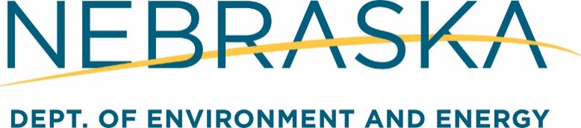

**Agency Legal Counsel**

*Hourly Salary - $39.872 - $56.957

*Annual Salary - 82,933.76 – $118,470.46

*Hiring salary dependent upon selected applicant's qualifications and experience

Are you passionate about preserving, enhancing, and protecting Nebraska’s environment? If so, consider a career with the State of Nebraska at the Department of Environment and Energy (NDEE). At NDEE, employees, have the opportunity to work with a dynamic and supportive team of mission-focused individuals tasked with maintaining, restoring, and enhancing the quality of Nebraska’s air, land, water, and energy resources.

NDEE has a full-time opportunity an Agency General Counsel.

The Nebraska Department of Environment and Energy (NDEE) is looking for a dynamic and committed general counsel. This position oversees 4 attorneys, a paralegal, and two technical staff. Experience with state and federal environmental laws is a plus but not required. This is an opportunity to run your own firm and gain a broad range of experience from administrative hearings to assisting with complex litigation.

Requirements: A Nebraska bar license and 5 years of experience practicing law and providing legal services such as preparing and trying cases, advising clients, and/or interpreting laws and/or administrative policies, including one year of supervising other attorneys.

**The NDEE advantage:**

* More experience and opportunities than a private law office
* Work is generally limited to 40 hours/week
* Set your own schedule and manage your own caseload
* Regular interaction with great clients, including heads of state agencies
* Immediately work on cases that establish public policy and have statewide impact

****************************************************************************************************

It is a very exciting time at our agency; some of the things you can look forward to as an employee of NDEE are:

* Combining environmental law with public service
* A new office building in Fallbrook with free parking.
* Flexible work schedules
* You will be doing work knowing you are making a difference for current and future generations.

**What you will do!**

This position will oversee the agency’s legal team, advising staff on a broad range of issues. The Legal team advises on significant environmental decisions, guides agency policy, prioritizes enforcement cases, and handles administrative orders. This position looks for creative ways to achieve agency goals and is involved in setting public policy.

**What’s in it for you!**

The opportunity to work in a productive and creative environment where no two days are ever the same! The State of Nebraska offers a competitive benefits package, including:

12 days of vacation during first year of service (accruals increase with years of service), 12 days of sick leave during first year of service (accruals increase with years of service), and 13 paid holidays per year. Permanent Teammate Benefits: • Health Insurance • Dental Insurance • Vision Insurance • WellNebraska Health Plan • Direct Primary Care (DPC) • Mail order Rx (3 month supply) and Specialty Pharmacy program • Virtual Visits and FREE Nurse line 24 hours a day 7 days a week • Employee Assistance Program • Retirement/Investment Plan • Early Retirement Insurance Program (55 and older) • Short-Term and Long-Term Disability • Health Savings Account • Flexible Spending Accounts • Life and AD&D Insurance • Tuition Assistance* • LinkedIn Learning Access to 16,000+ On-Demand Courses • Direct Deposit of Payroll • Nebraska State Employees Credit Union • Deferred Compensation Plan • Paid Holidays • Vacation, Sick, Civil, and Injury Leave • Military Training or Emergency Duty Leave • Teammate Discount Program • Charitable Giving through Payroll Deduction (*Coverage is effective the first of the month following 30 days of employment.)

For a complete listing of job duties, requirements and to apply go to statejobs.nebraska.gov

